residential detached accessory structures

Introduction:
The term residential accessory structure includes a private garage, storage structure, workshop, play set, greenhouse, decks, pools, patio covers, gazebos, pergolas, arbors, etc. (see Unified Development Code [UDC] 11-IA-1). The structure must be detached and located on the same property as the residence. Please refer to the diagrams as you review the frequently asked questions below.

Diagrams:
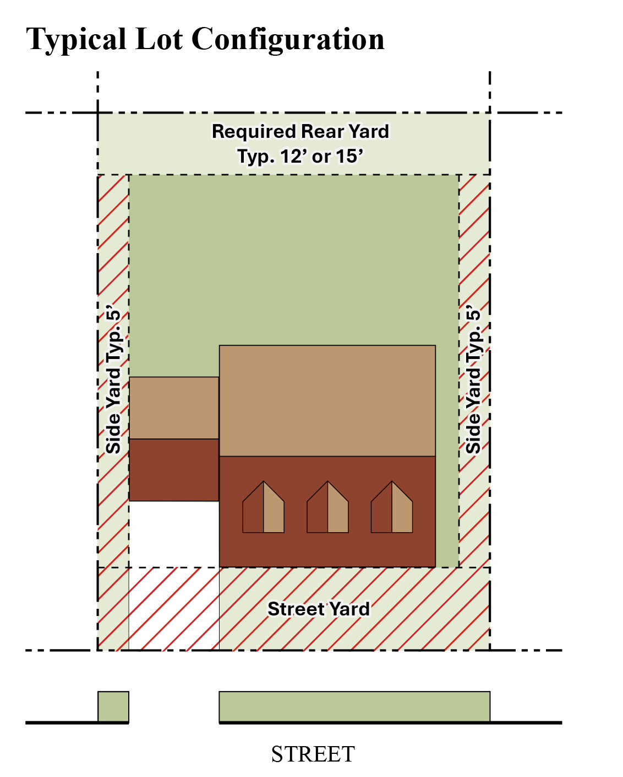
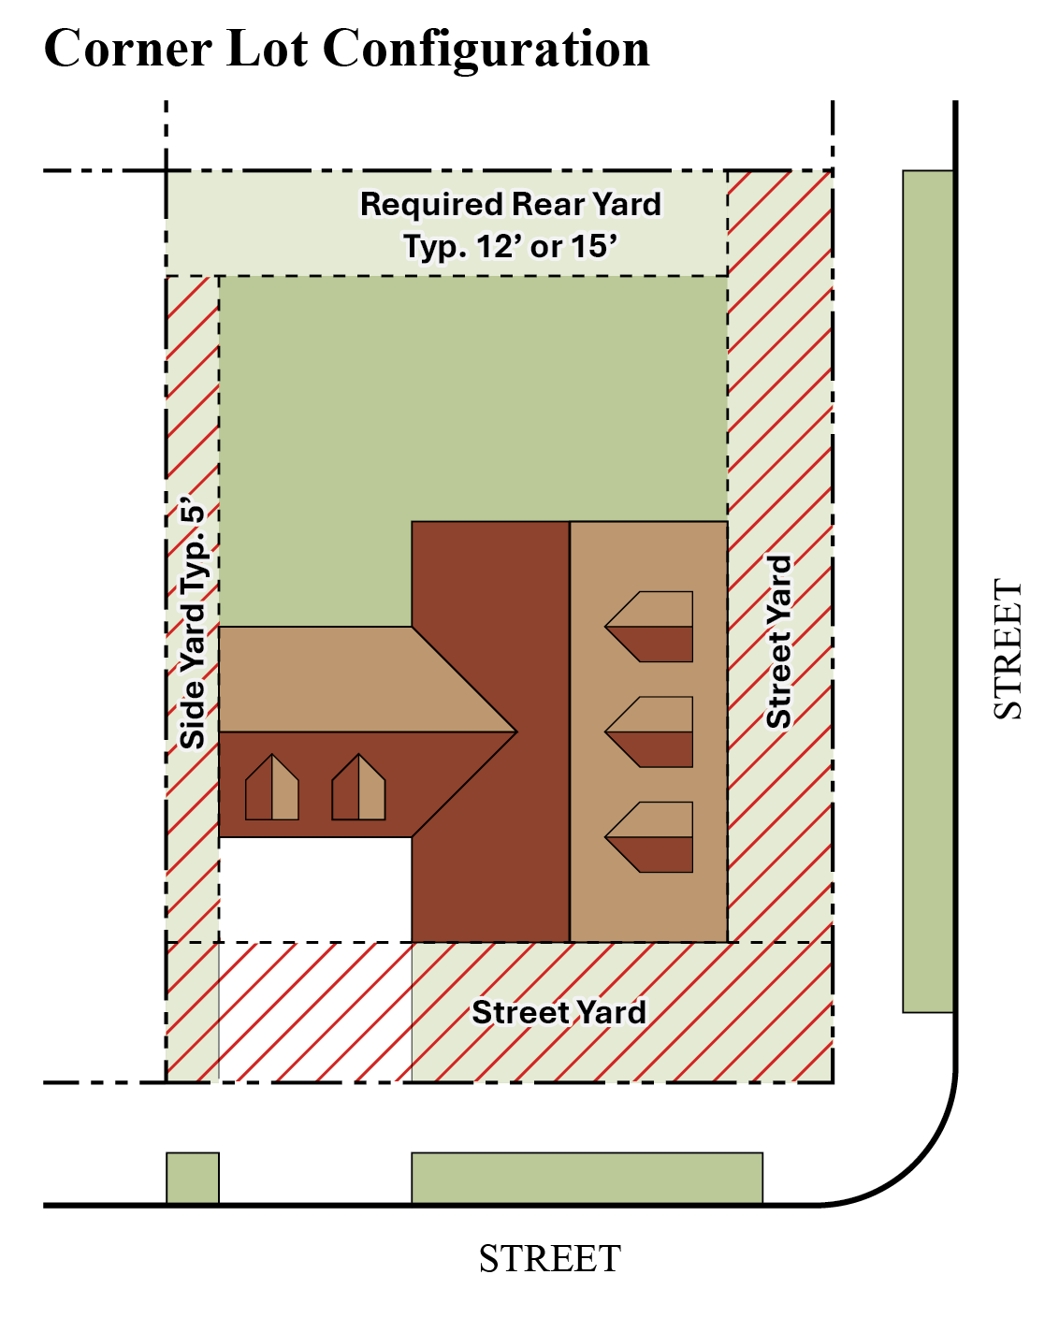
Typical Street Yard Setback is 15 feet to living space and 20 feet to garage face measured from property pin or back of sidewalk, whichever is more restrictive.
Typical Easement is 10 feet in the rear yard, 5 feet for interior side yard, 15 feet for street side yard for corner lots.

Frequently Asked Questions:

Can I put a shed next to my rear fence?
One detached accessory structure that is 200 square feet in area, or less, may be placed in the required rear yard without a building permit (see UDC 11-2A-3D3). Detached structures and sheds over 200 square feet require a Residential Shed permit (R-SHED).

Can I put a shed on the side of my house?
An accessory building is not allowed in the street yard or the required yard as indicated by the hash marks in the “Typical Lot Configuration” diagram (see UDC 11-2A-3D3).

How tall can my shed be?
See applicable Homeowner Association (HOA) restrictions.

Are other structures allowed?
Additional accessory structures may be located on a residential property, provided they are not located in front of the residence, or within the required rear or side yards. For corner lots, no accessory structure shall be located in front of the residence, between the residence and the street, or within the required street yard. Please refer to the diagrams for typical residential configurations and UDC 11-2A for standards applicable in residential zones.

When do I need a building permit?
Detached accessory structures, including sheds, shade structures, and decks that are more than one story or over 200 square feet or attached to the residence do require a permit from the Building Services Department.

Do these same rules apply to fences?
Fences, including trellises, lattice-work, arches, and other detached screening, are not considered accessory structures and are subject to different regulations. See UDC 11-3A-7 for all regulations regarding fences. These types of projects require a Residential Fence permit (R-FEN). Fence permits do not require a plan review but drawings are required to show location of placement.

Do I need a building permit for a pool?
Prefabricated swimming pools that are not greater than four (4) feet deep do not require a building permit. All other swimming pools do require a building permit and cannot encroach into the easements of the property (typical 10 foot rear and 5 foot side yard easements, please check recorded plat for verification).

Do I need a building permit for a shade structure (patio cover, arbor, pergola, gazebo)?
Provided that the structure is detached from the residence and less than 200 square feet, it will not require a building permit. If over 200 square feet a Residential Patio Cover building permit (R-PATIO) will be required, and the required yard and side yard setbacks will have to be obtained.

Other helpful information:
Work exempt from permit. Exemption from permit requirements of this code shall not be deemed to grant authorization for any work to be done in any manner in violation of the provisions of this code or any other laws or ordinances of this jurisdiction. Permits shall not be required for the following:
- Retaining walls that are not over 4 feet in height measured from the bottom of the footing to the top of the wall, unless supporting a surcharge. If over 4 feet a Residential Miscellaneous (R-MISC) will be required.
- Water tanks supported directly upon grade if the capacity does not exceed 5,000 gallons and the ratio of height to diameter or width does not exceed 2 to 1.
- Sidewalks and driveways.
- Painting, papering, tiling, carpeting, cabinets, counter tops and similar finish work.
- Swings and other playground equipment.
- Window awnings supported by an exterior wall that do not project more than 54 inches from the exterior wall and do not require additional support.
- Decks not exceeding 200 square feet in area, that are not more than 30 inches above grade at any point, are not attached to a dwelling and do not serve the edit door required by Section R311.4.

Storage Sheds – Residential

Shed Installation Requirements:
- Verify setbacks and easements for placement. Call Meridian Planning at (208) 884-5533.
- Verify HOA requirements.
- All structures must be “detached” from the dwelling otherwise it is an “addition” and subject to all of the requirements in the International Residential Code.

No Building Permit:
- 200 square feet or less (one-story) does not require a building permit. Setback, placement and HOA rules must be observed. Any electrical work requires an electrical permit.

Building Permit “Required”:
- One-story sheds larger than 200 square feet and less than 600 square feet, eave height of 10 feet or less, unheated with no power require a shallow (slab) foundation with turned down edges to 12 inches deep. The shed must be approved and attached adequately to the foundation.
- One-story sheds larger than 200 square feet and less than 600 square feet, eave height of 10 feet or less, with power and heat require a footing and foundation to frost line (24 inches deep). The shed must be approved and attached adequately to the foundation. Electrical permit required.
- One-story sheds larger than 600 square feet require footing and foundation to frost line of 24 inches deep. The shed must be approved and attached adequately to the foundation.
- Sheds with tall walls (taller than 10 feet 0 inches), overhead storage, or mezzanine/lofts may require structural engineering and design. All two-story structures are subject to compliance with the International Residential Code.

